1. **C program to print all natural numbers from 1 to n**

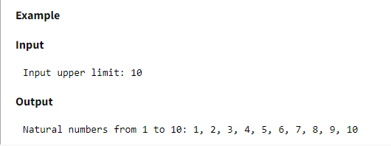

1. **C program to print natural numbers in reverse from n to 1**

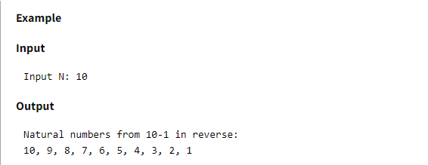

1. **C program to print alphabets from a to z**

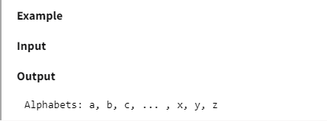

1. **C program to print all even numbers from 1 to n**

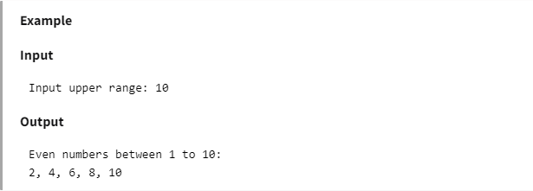

1. **C program to print all odd numbers from 1 to n**

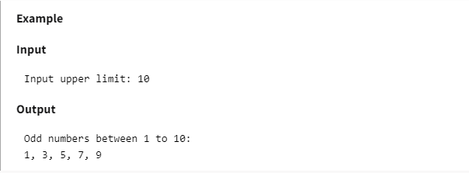

1. **C program to find sum of odd numbers from 1 to n**

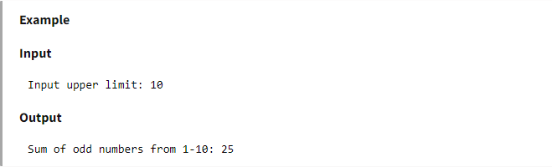

1. **C program to print multiplication table of a given number**

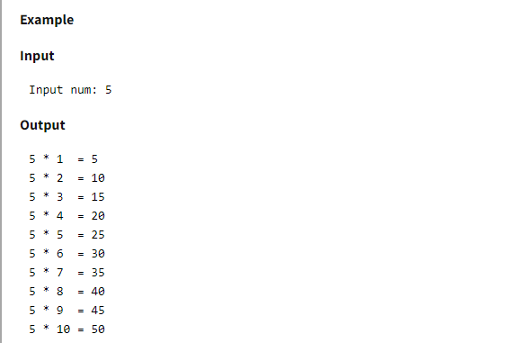

1. **C program to print all even numbers from 1 to n**

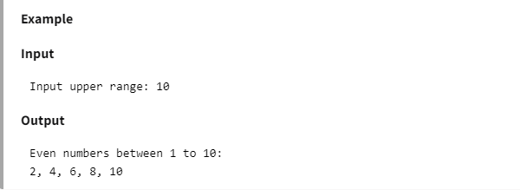

1. **C program to print all odd numbers from 1 to n**

